System Overview

SCOUT

## Summary

SCOUT is a tool that is used to create, manage, and work audits on loans that being considered for foreclosure. An audit will be created for all loans that are in a specified state, or meet specified requirements, for foreclosure in the SPS system. Currently there are two audit processes that SCOUT will manage, pre-foreclosure and forbearance closeout. SCOUT is oriented around a daily batch process.

## Overview

**Major DB diagram:**

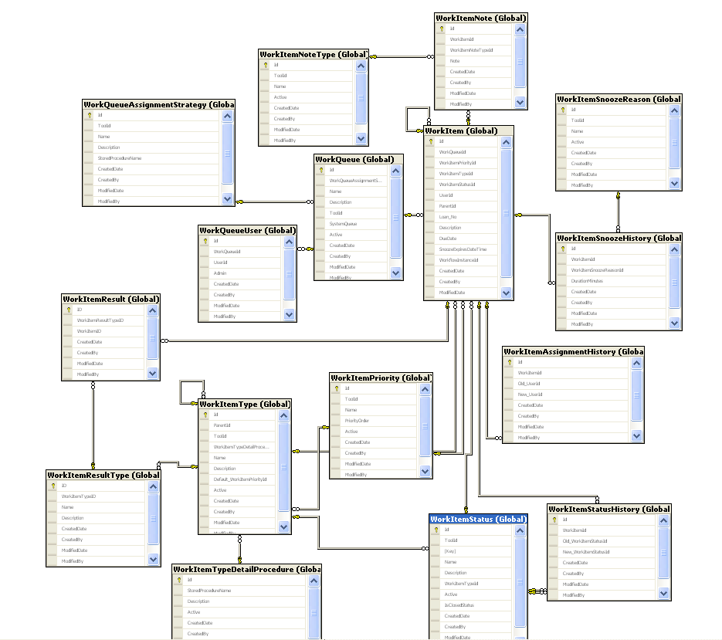

**Flow chart diagram:**

Database

Web services

Work Queues

Workflows

SSIS

UI

* Black : Database CRUD
* Blue : Process Flow
* Green : Work Queue Interaction

**UI for SCOUT tool:**

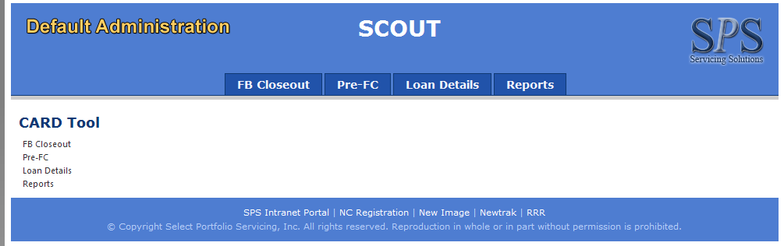

## Audience & Ownership

|  |  |  |
| --- | --- | --- |
| Target Audience | *Who are the primary users of the system for which the functionality should be targeted?* | * IT/Service Desk |
| Administrators | *Who is responsible for configuring the system and ensuring its availability?* |  |
| Technical Owners | *IT team responsible for supporting the system.* |  |
| Technical SMEs | *IT associates most familiar with the system. They are responsible for guiding the technical direction of the system.* |  |
| Business Owners | *Business associates responsible for the functionality of the system. They must approve any change to the system before development begins.* | * IT/Service Desk |
| Stakeholders | *Leaders of departments who may be impacted by system changes. This typically includes the business units who use the system, as well as training and Analytics. The stakeholders will need to approve the changes before deployment, as well as the timing of the changes.* |  |
| Vendor Contacts | *Support information for vendors associated with this system.* | * N/A |

## Installation

System: Windows XP / Windows 7

Environment: IIS

Installation: \\slflpr4\data\SoftwareDevelopment\Builds\DefaultAdministration\CFPB-Scout-UAT

## System Requirements

This section includes all of the requirements and dependencies needed for the system to run.

|  |  |  |
| --- | --- | --- |
|  | Requirements | Details |
| Web Server | * Windows Server 2003 or better * IIS 6 or better | N/A |
| App Server | * N/A | N/A |
| Citrix | * N/A | N/A |
| Desktop | * N/A | N/A |
| File Locations | * N/A | N/A |
| Dependencies | * N/A | N/A |
| MoveIT | * N/A | N/A |

## Database Connectivity

This section describes the methods used for accessing data from the database.

|  |  |  |  |
| --- | --- | --- | --- |
| Server | Database | Authentication | How Used |
| SLSQLDEV01\DEV_2005  SLSQLTEST01\TEST_2005  SLSQLRC2  SLSQLRC2\STATIC  SLLTS | DefaultAdministration | Integrated | Web.config |
| SLSQLPERSIST | DefaultAdministrationPrst | Integrated | Web.config |
| SLSQLDEV01\DEV_2005  SLSQLTEST01\TEST_2005  SLSQLRC2  SLSQLRC2\STATIC  SLLTS | FBRSQL | Integrated | Web.config |
| SLSQLDEV01\DEV_2005  SLSQLTEST01\TEST_2005  SLSQLRC2  SLSQLRC2\STATIC  SLLTS | HRAdministration | Integrated | Web.config |
| SLSQLDEV01\DEV_2005  SLSQLTEST01\TEST_2005  SLSQLRC2  SLSQLRC2\STATIC  SLLTS | Enterprise | Integrated | Web.config |

## Security

This section describes the security needs and features of the system.

### System Security

|  |  |  |
| --- | --- | --- |
| Security Type | Security Process | Administered By |
| DB | AD Integrated | DBA |

### Security Objects

|  |  |  |  |
| --- | --- | --- | --- |
| name | Type | Description | How Used |
| N/A | N/A | N/A | N/A |

## TFS Path

**TFS2010:** $/Dev/SCOUT

## Version History

|  |  |  |  |
| --- | --- | --- | --- |
| Version | Date | Author | Modification |
| 1.0 | 03/26/2014 | Fan Yu | Initial Creation |
| 1.1 | 03/16/2017 | Edwin Guru Singh | Added SLSQLPERSIST into Db connectivity |
|  |  |  |  |
|  |  |  |  |